**Technical Information**

Counterweight guiderails and motor support for Synergy

#### **To**

Copy JM INSALACO – P. BOSSELUT – A. BOUDAILLIEZ – A. CARON – A. FAYOL – J. MORILLE – M. LE QUINIO – Y. BOISRIVAUD -

G. COMTE - R. FROGER – R. GRANDPIERRE – P. LAMY – S. PAVY - G. RICHARD – E. ROISNARD – S. SUROT

From JP FLOCH

Department Quality Coordinator TKEMF Angers, the 5th of March 2015

N/Ref. JPF/2015 01

**Description of the failure**

The motor support for Synergy A & B is installed on the counterweight guiderails and also fixed on the wall.

In case of subsidence of the building, the part fixed to the wall goes down while the part in contact on the guiderails stays at the same level. The consequences for the installation are:

- An inclination of the motor with its support going backwards to the wall. This could generate noises (friction of the ropes on the brackets, shock of the motor against the wall).

- A distortion of the counterweight guiderails because of additional compression load. This could generate a malfunction of the lift if the counterweight does not slide correctly between the guiderails (for example rope slippage on the traction sheave, noises).

**Inspection**

Make sure that the motor support is horizontal:

- The clearance between motor or brake and the wall must be higher than 10mm, otherwise action(s) must be carried out.

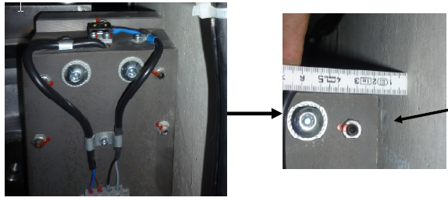

Clearance > 10 mm = OK

**Clearance < 10 mm = Wrong**

- The distance between the traction ropes and the brackets must be higher than 10mm, otherwise action(s) to be carried out.

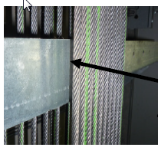 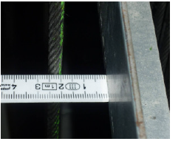

Clearance > 10 mm = OK

**Clearance < 10 mm = Wrong**

Check the vertical alignment of the guides rails:

- By visual inspection from the top of the shaft and from the car roof, check that the guiderails are not bended.

- The vertical alignment of the car and counterweight guiderails with a measuring tape: the distance between guiderails (measured between 2 brackets and at the fishplate level) cannot deviate from more than 3mm (more or less), otherwise action(s) to be carried out.

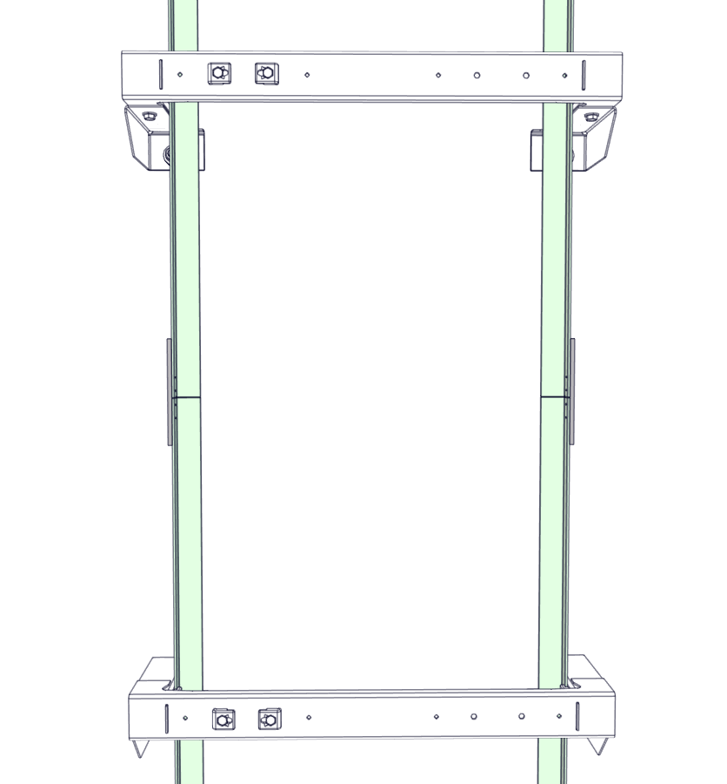

Variation < 3 mm = OK

**Variation > 3 mm = Wrong**

**Actions to be carried out by the Field:**

If you detect that the motor support is not horizontal or that the guiderails are not vertically aligned, you have to correct the point:

- In all cases, please add a guiderail bracket if the distance between brackets is higher than 2500mm for 630 Kg or 2000mm for 1000 Kg. The brackets can be ordered free of charge to RMR Department with a warranty request.

- If the motor support has vertical slotted holes (and the screw pins are not in lower part of slots): loosen the screw and adjust the support according to the documentation reference 3029397 version 00 “Re-leveling the motor support”.

- If the motor support is fitted with inclined slots (or that screw pins are located in the lower part of the vertical slots or the previous actions are not sufficient enough): cut the counterweight guiderails according to the documentation reference 3028827 version 03 “Shortening counterweight guides”.

- To cut the guides, the tool reference 3028945 and the shims reference 7014A6000 (2 x 15 shims) can be ordered free of charge to RMR Department with a warranty request.

- If the shims are positioned under the counterweight guiderails: To remove shims if the guiderails T50 are once again bended, please follow the documentation reference 3028827 version 03 “Shortening counterweight guides”.

Whatever the operation carried out, please check that:

- The clearance between the motor and the wall is > 10mm.

- The clearance between the traction ropes and the brackets is > 10mm.

- The distance between the guiderails does not deviate from more than 3mm.

For all new order of Synergy, from the 2nd of March 2015, the shims (with the relevant pit channels) will be automatically delivered, free of charge.

**Actions by the Manufacturing:**

- From July 2013, the Synergy A & B are delivered with the correct distance between brackets.

- From November 2013, the Synergy A & B are delivered with the motor support having vertical slotted holes.

- A project team is currently working to improve the design of the Synergy motor support by taking into account the building subsidence. The lead time to implement this action is scheduled for October 2015.

To install additional brackets, shorten the guiderails and put the shims, 1 working day for 2 people is necessary.

We apologize for any inconvenience caused.

Best regards

Jean-Philippe Floch